Lez 1
- HSI goal: understand how we can design an optimal interaction between human and technological systems.
- Design science approach: similar to scientific method, identify a problem, look up potential solutions (existing knowledge), objective settings, design and development, artifaìct evaluation, analysis, hypothesis refinement, delivery

Hypothesis vs prototype

Hypothesis:
Definition: testable statement that proposes relationships between variables, grounded in empirical observation.
Testability: evaluated with experiments to determine if it can be falsified or not.
Iteration: subject to change and refinement based on experimental results.

Prototype:
Definition: tangible representation or preliminary model of an idea, design, or solution.
Testability: assessed for their effectiveness in practical application.
Iteration: undergo refinement and modification based on their performance, enabling the restart or redesign of the prototype to enhance its functionality or efficiency.

Evidence Base Design (EBD)
Design choices on best research available. Use critical eye, sometimes conflicting solutions. Use more reliable evidence available

Eminence Base Design: design choices influence by leading figures

Evidence: empirical observations, collect data from empirical experiments.
Evidence: any empirical observation about the apparent relationship between events
There is a method to evaluate the evidence strength. There is a whole range of evidence.
- Highest evidence (best evidence) comes from meta-analysis. From systematic use of the randomised controlled trials (RCT).
  - RCT: involve not just human subjects in a controller environment. Compare two systems (controller-intervention). Randomization ensures that the two groups are equivalent for a fair comparison, any difference cannot be due to chance but it is a real difference. When many RCTs are collected we do meta-analysis.
- Weakest evidence (option of recognised experts and case studies) Eminence base design. Even lower is your option
- Level 9 and 8 are AI-related ⟹ significant room for improvement to achieve stronger evidence levels

Design decisions should not blindly follow trends but should integrate credible research,
client needs, and the designer's experience.
- Fallacy: avoid assuming that once a solution is provided, it will remain stable and used as intended
- The better a system is, the easier it is for the user to achieve their own objective by using the system
- We start from a human world where we intervene by putting a technological system to improve the user experience and their capability to achieve their own objectives. But humans are already using some tools
- human-system interaction = the design of interventions through which to improve the human context.
- As designers, we're tasked with shaping a better future for users. You intervene in their world with the intention of making effective, positive changes.

Ch1: SYSTEM in human system interaction
- A system can be static or dynamic
- A dynamic system can be linear or closed-loop.
- A closed loop system can be recirculating or self-regulatory
- A self-regulating system can be first order or second order.
- A second order system can be self-adapting or learning system.

System: a combination of interacting elements organised to achieve one more stated purpose.
Socio-technical system: include a combination of technical, human, and natural elements.
⟹ Interactive system: combination of hardware, software, services, and people that users interact with to achieve specific goals.

FBS Framework (Function-Behaviour Structure)
- Function: why the system exists. What the system is intended to achieve through its behaviour. It is closely related to the concept of intended use. The first thing to do when you design a system is to state the function.
- Behaviour: what the system does. How the artefact operates to achieve its function.
  - Expected behaviour: the behaviour that the designer anticipates, it is derived from the function
  - Actual behaviour: the behaviour that the system actually exhibits. It is derived from the structure. What people do
- Functional behaviour: behaviour that you can see, measure and observe
- Inner behaviour: non-perceivable, involve complex internal process
- Structure: how the system does it. How the system exhibits the behaviour. Any tangible components of the artefact. It’s the configuration that allows the artefact to exhibit the behaviour.

Interactive systems
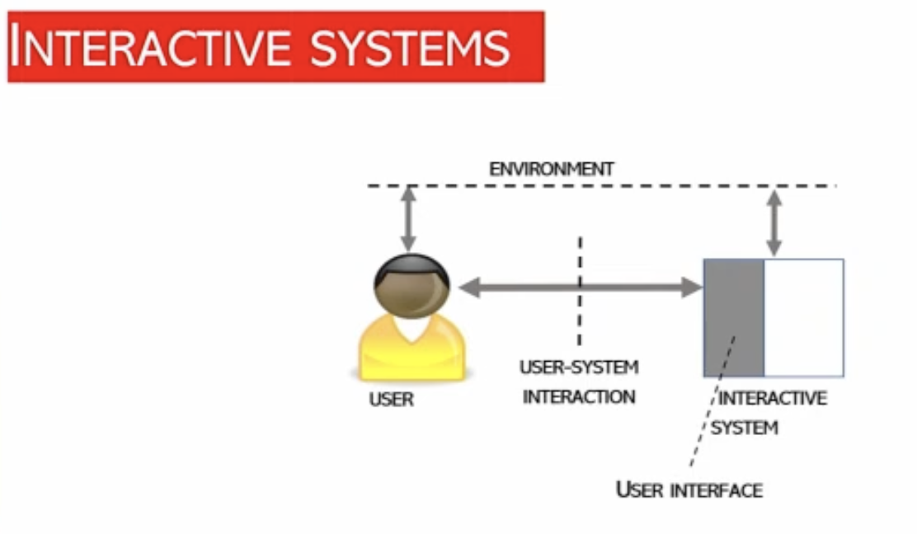

- Interactive System: integrated assembly that includes hardware, software, services, and people. It's designed for users to interact with in order to achieve specific goals.

- User Interface Components: subset of an interactive system's components. It includes all the elements that provide information and controls for users to accomplish specific tasks within the interactive system (like keyboard).

- Commonalities Between Definitions: both interactive systems and user interfaces are geared toward enabling user interaction to achieve tasks. The common elements in these definitions include the user, interaction, and the concept of accomplishing specific goals or tasks.

- Task: is a series of activities undertaken to achieve a specific goal. It has a structure and sequence aimed at reaching an objective, distinguishing it from random or unstructured actions.

- Context of use: comprehensive term that includes the combination of users, their goals and tasks, resources, and the environment in which the system operates.

- User Experience (UX): user experience encompasses the user's perceptions and responses resulting from the actual or anticipated use of a system, product, or service.

- User-System Interaction: user-system interaction is the exchange of information between the user and the interactive system via the user interface, necessary to complete the intended tasks.

Ch2: SYSTEM in AI system
AI as an Idea: The concept of AI as a theoretical construct.
AI as an Academic Field: The study of AI as a scholarly pursuit.
AI as a Narrative: The portrayal of AI in academic, literary, and cinematic narratives.
AI as an Entity: The physical manifestation of AI systems.

Narrow AI: AI systems performing domain-specific tasks.
General AI: Systems capable of performing domain-general cognitive tasks.
Human-Level AI: Systems achieving a level of cognition comparable to human intelligence.

The term ‘artificial’ regards the fact that artefacts are made by humans but not all software-interactive artefacts are artificial.

Emulation ≠ simulation
- Simulation: reproduction of how things works in nature (like a robot-dog that simulate a dog)
- Emulation: get the same outcome without reproducing other behaviour (a plan does not simulate the movement of a bird but it flies anyways)

The term ‘artificial intelligence’ was coined in 1955.

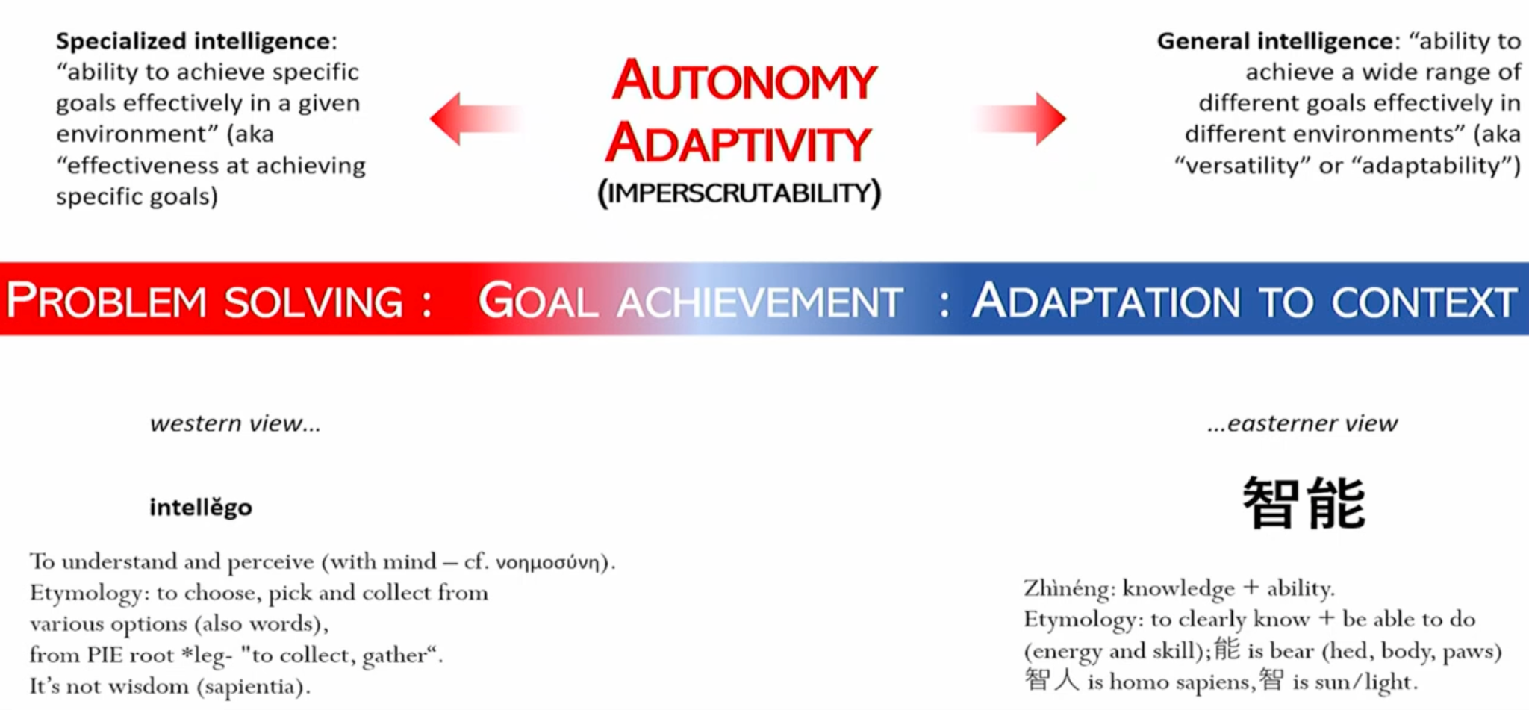
We can have a spectrum as a definition of intelligence.
- Western/cognitive scientist view: intelligence as the capability of solving mathematical problems (choosing the right move in a board game). Intelligence as understand and perceive
- Eastern view: adaptation to the context, find an harmonic way to cope with the environment. Intelligence as to choose from a collection/spectrum of options

- Tesler’s theorem: is AI is whatever hasn’t been done yet.
- Multiple intelligence theory (Gardner): there is no just one intelligence, there are multiple kinds of intelligence. There are people good in logical/mathematical intelligence and people good at musical intelligence, …Now we have an AI good in logical/mathematical intelligence and visual intelligence and interpersonal intelligence

AI: system as one capable of automating the execution of cognitively complex tasks.

ISO Definition of AI systems:
AI systems are engineered tools designed to meet specific, human-defined objectives. (magnifying glass)

European AI Act Definition:
AI systems are machine-based entities that operate with various levels of autonomy. These systems are not just tools for explicit tasks but are also designed for implicit objectives, meaning they can adapt and learn from their environments. Vague definition to leave room for interpretation. (telescope)

Autonomy: system can modify its objectives and operational domain without external control or Intervention. (No machine is currently autonomous).

Heteronomy: AI systems are better described as 'heteronomous' since they operate under constraints and objectives set by humans.

Influence: AI systems can influence decisions merely by producing new information. But this implies that even a simple spreadsheet could be considered as AI.

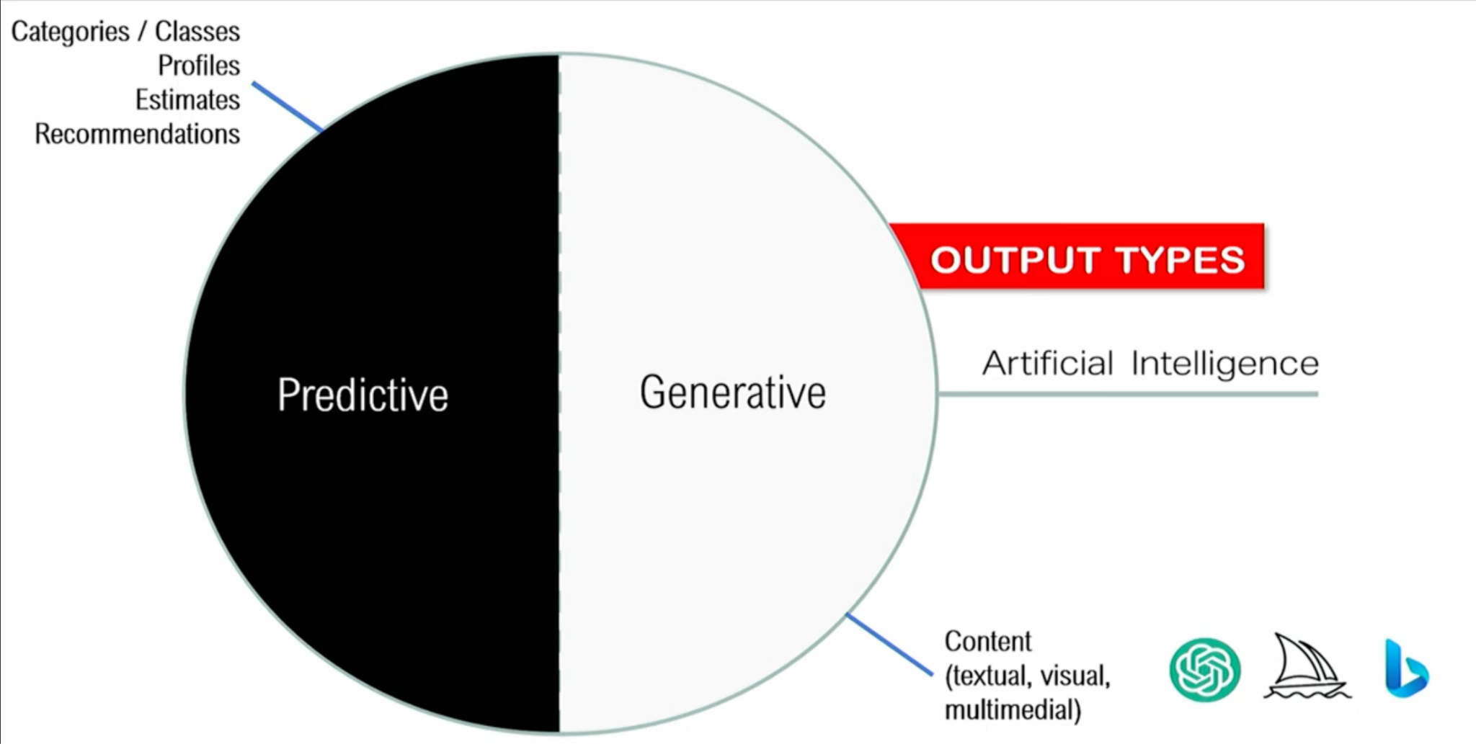
We can distinguish between two broad kinds of AI based on the output type such as
- Predicting: capable to produce classification (assign elements to classes) or grouping people according to their characteristic and produce estimates and using recommendations
- Generative: able to produce content of multiple contents
⟹ there is something predictive in generative AI and there is something generative in predictive AI. At the end they produce probabilities.

Article 13 - Transparency
- Practical guidance for designers to align with legal standards.
- Emphasises importance of transparency (providing clear, concise and correct instructions about the system) in AI systems.
- Must state what the function of your system is and in the regulation is specified how the intended use must be described.
- You describe what the system does and what it is intended to do.
- … and what the system in NOT intended to do
- For a LLM it is very hard to specify a specific intended purpose. We will have to find a compromise in the EU AI ACT between generality and specificity.
- Specify what objective and goal or aim and in which environment processing which kind of data.

Misuse
- Developers responsible for how people will use your system in terms of reasonably foreseeable misuse.
- Companies must demonstrate that they have done everything possible to mitigate risks associated with reasonably foreseeable misuses.
- Consider foreseeable what people do on a regular basis without moral judgements, just in terms of how frequent some uses are.

- Red teamers: understand how people would misuse the system, Red teamers are experts who test systems for vulnerabilities, including potential misuses for harmful or illegal purposes. Hired by companies.

- Intended use: set actions we can do in a system for a specific goal
- Misuse: is when the scope is not the intended use

- A company has to be transparent on how they develop the system, the training, validation and testing phase.
  - There is also the cost of data. Some models are trained with data with licence of use (no copyright). But most successful models (chatGPT) are trained on copyrighted data.

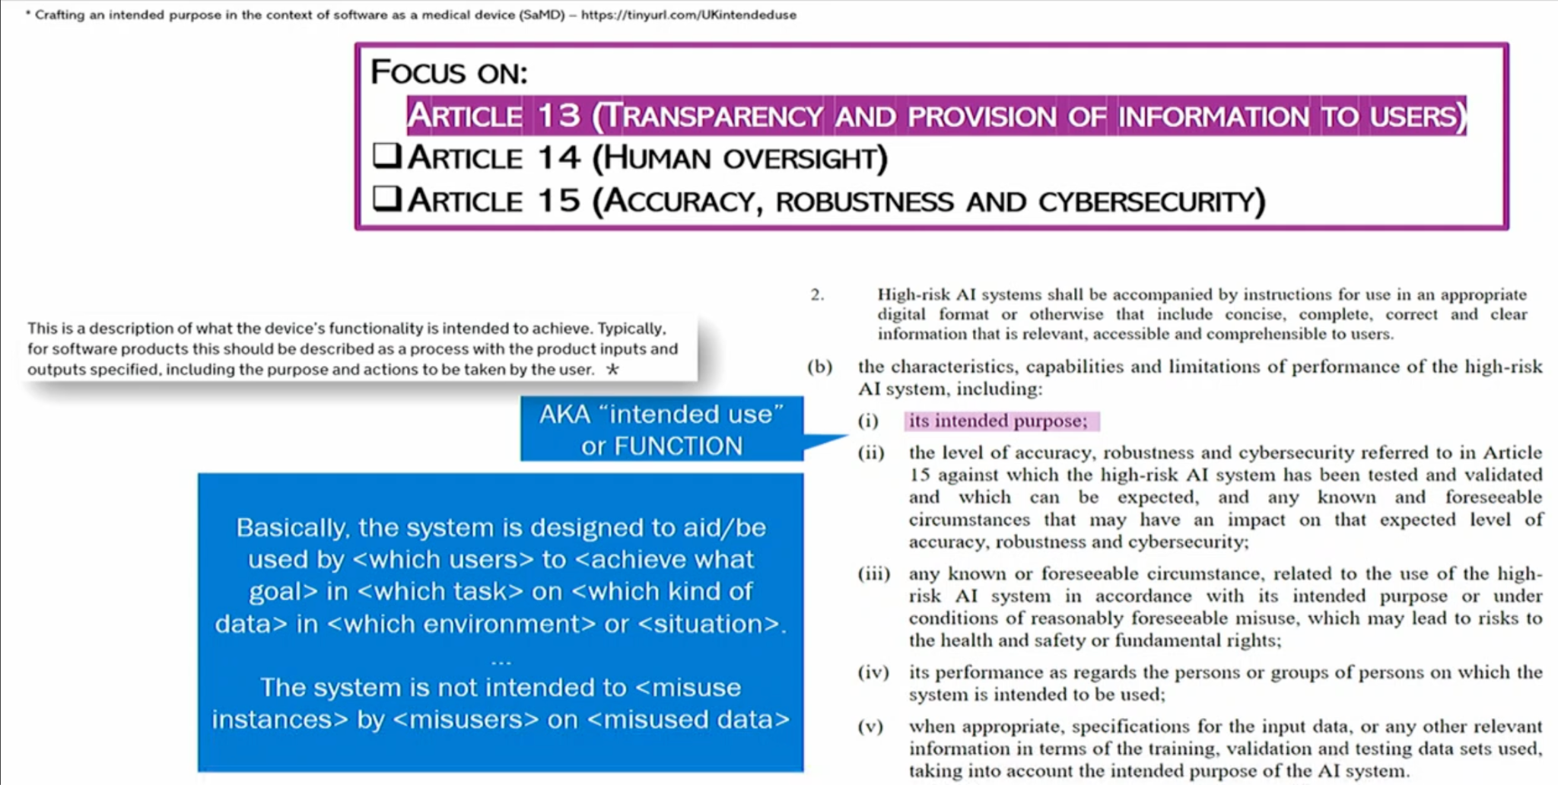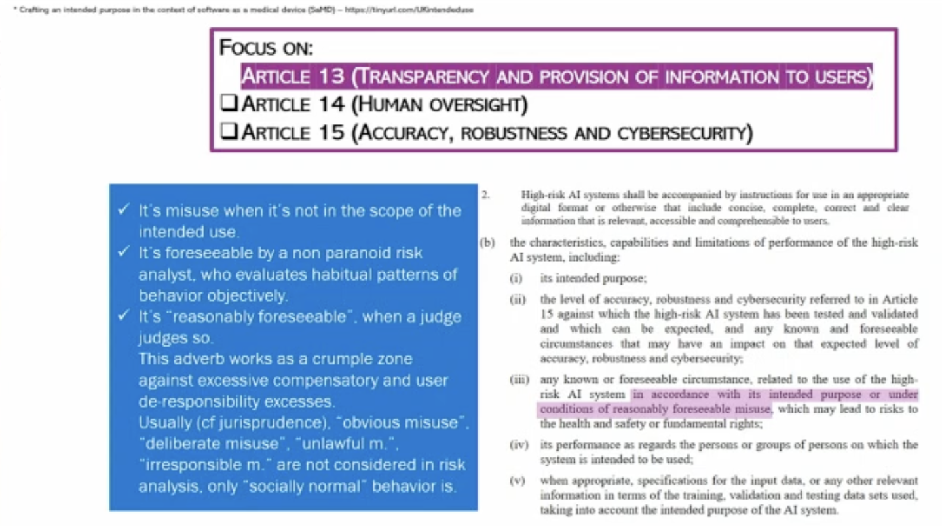

Demonstrating transparency
- Effectiveness: involves validity for the intended use, reliability concerning data usage, robustness, and influential impact.
- Efficiency
- User satisfaction
- Cybersecurity
- Ethics

- Effective, efficient, satisfactory related to concept of usability.

Effectiveness
- Influent is the most vague but in reality influence is all you need. Everything can be influential, a spreadsheet could influence a CEO according to the values it produces, here is the idea of autonomy influencing.
- Reliability is the technical centre part of the concept of trustworthiness. But engineers don't like trustworthiness because it is based on trust (aka psychological construct) it is something of the human side. Technical people prefer more the concept of reliability (in some sense it is like trust) but it can be divided in two components:
- reliability in behaviour, because its behaviour is expectable with respect to the intended function
- reliability of source of data used to train AI systems.

The elephant in the machine
The big elephant in the room is the quality of the data used to train our system. Propose a new metric to evaluate data reliability.

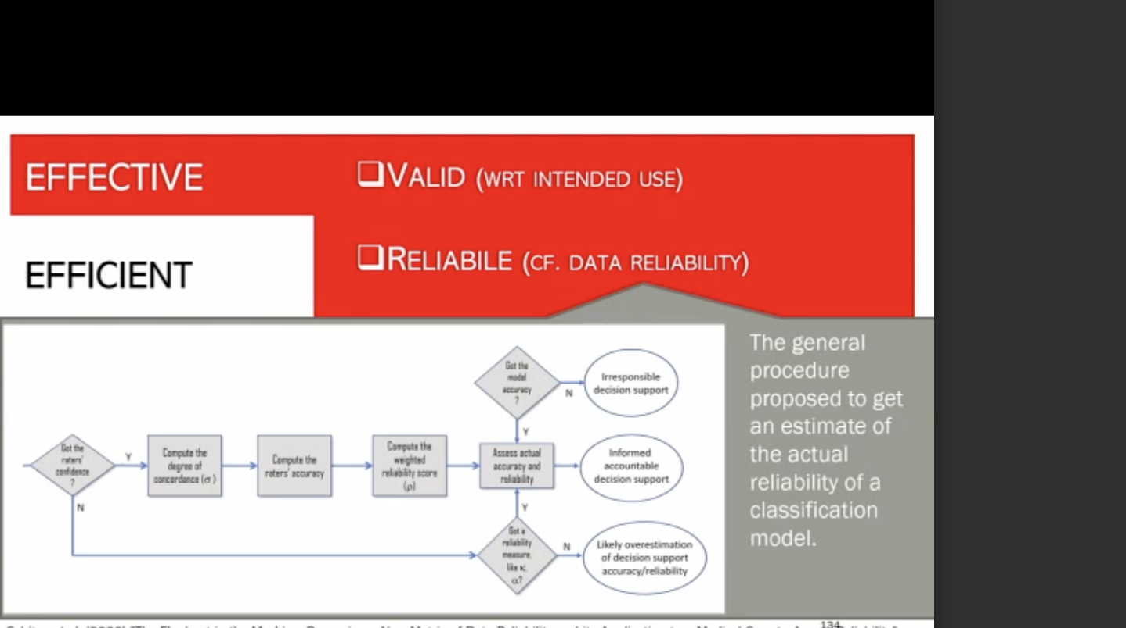

Simply decision algorithm with 3 possible outcomes
- Building an irresponsible system: in decision support. Aka you are irresponsible in developing and designing a decision support
- Overestimating accuracy or reliability of the decision support you are building
- Creating an informed and accountable system: yon can demonstrate to build an informed accountable decision support.

You should ask if you get the model accuracy. You are just crazy if you don’t consider the model accuracy (everybody does so, important, how often the system makes mistakes).

Need also rater: people who label the image (for supervised classification), they establish the ground truth.

Important to consider reliability measures. Important to consider confidence in labelling phase and reliability score. Compute also weighted reliability score.

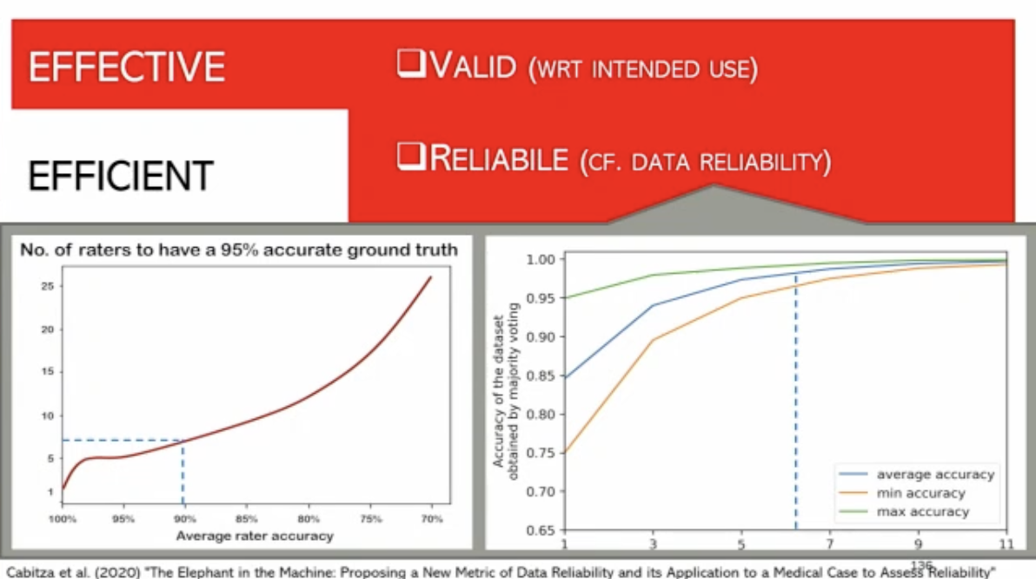
Show the number of raters involved to get not a perfect ground truth dataset but a decent one (aka one where the error rate is at least 95%).

⟹ people take in account that the dataset have accuracy 100%, but it is a serious mistake.

Diagram shows that according to the accuracy you need a different number of rater, oracles (people with almost 100% accuracy exist in specific fields only).

Usually doctors are 85% accurate, they make mistakes (50 out of 100). We need between 5 and 7 rater to have a decent ground truth.

Better to have an odd number of raters (so that they can do majority voting). 6 or 7 people you get good accuracy, but they are very expensive.

People online work for 1 or 2 $ and pretend to be experts. But real raters are expensive, most scientific articles involve 1 or 2 raters.

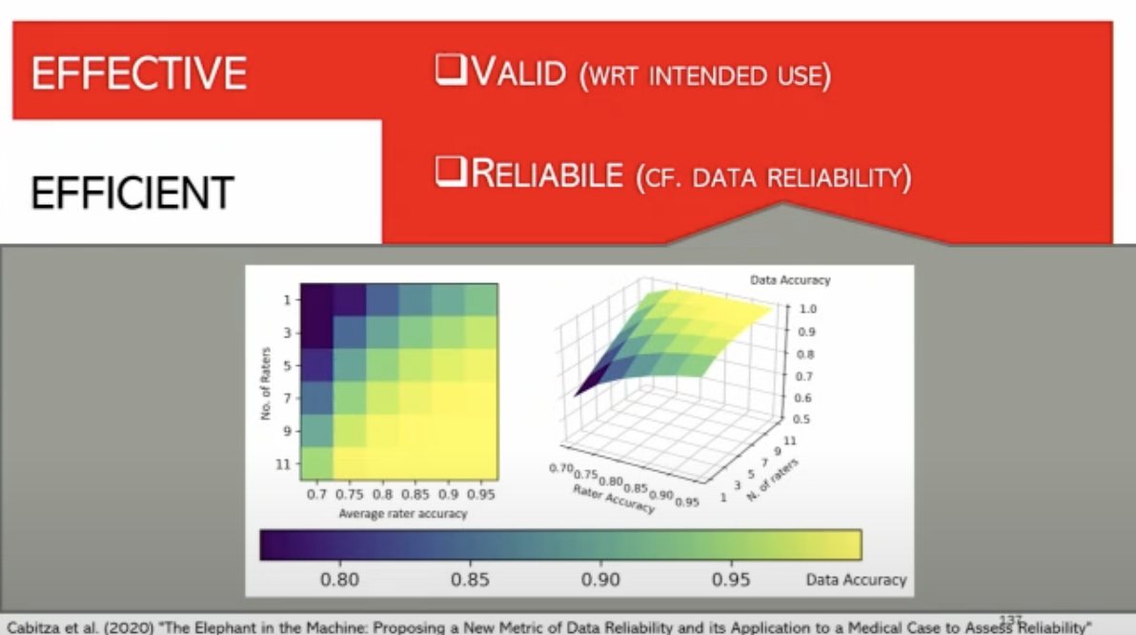
100% raters only for good raters, need many.
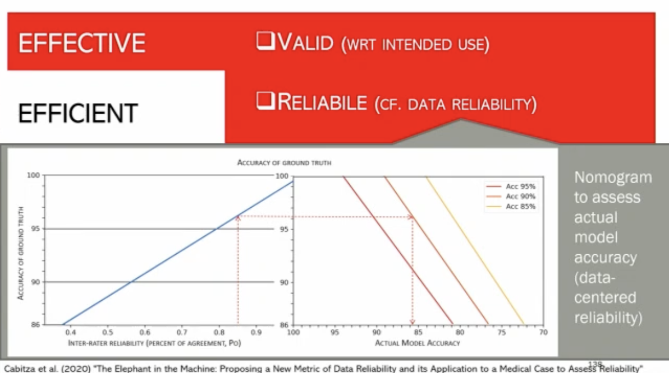

Nomogram (computational diagram), starts with a measure of inter-rater reliability. with a number of times raters agreed. But it is not really correct. Raters could agree by chance. They might be both wrong. The PO is upper bound, you should adjust this amount by considering the fact of change.

This metric is just a better metric in modelling change. Start to form an agreement and let trajectory bound. To get actual model accuracy. That is the accuracy in the real world, aka accuracy in the real world.

⟹ In medicine doctors do not usually agree with each other, ground truth is not perfect ⟹ we should never assume the ground truth to be perfect

Article 14 - Human oversight
This article deals with the levels of autonomy or automation in AI systems, focusing on the necessary human interaction and oversight in the functioning of these systems.

Article 15 - Accuracy, robustness and cybersecurity
It addresses the reliability and security of AI systems, ensuring they are robust against threats and accurate in their functioning.

Robustness
- Report confidence interval when specifying accuracy and robustness
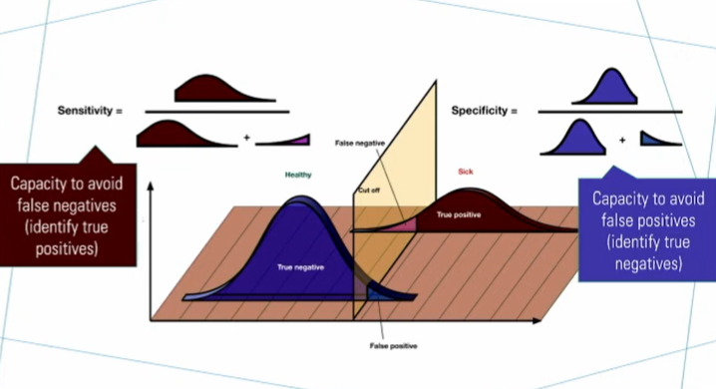

Accuracy
Accuracy: is the dual of errore. 1 - error rate
- not all the errors are equals. There are false positives and false negatives.

Sensitivity & Specificity
- Sensitivity: capacity to avoid false negatives, identity true positives
- Specificity: specify to avoid false positives., identity true negatives

F1-score


Harmonic means of sensitivity and specificity. Balance between precision (specificity) and recall (sensitivity).

ROC curve
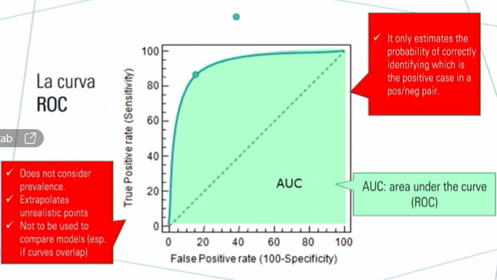

- Estimate of the probability of correctly identifying which is the positive case in a pos/neg pair
- Doctors do not have 2 people in front of them and they do not need to decide which one is ill and the other not, it is abstract.
- ROC do not consider prevalence, don't know how frequent is positive in the population, if you have very frequent disease this metric could be interpreted in one way or in another.
- You shouldn't compare models with ROC. Never use this metric unless you plot the curve. If you plot two models you can decide which model is better. You can compare the areas only if one curve is consistently less than another curve.

Accuracy is not a good proxy for.
- Robustness: having good performance on naturally diverse data (use different dataset to test)
- Reliability: being train on representative and true data
- Utility: having positive impact on decisions and outcomes

Report accuracy (but is not the only metric for the performance)
⟹ Balanced accuracy: provides a more nuanced view by weighting the prevalence of positive and negative cases in your sample.

- The accuracy is an average, it is possible that in easy cases it will perform above the average but in complex cases it will underperform because there are less cases, but those rare cases are the ones doctors need more help with. We should also evaluate the complexity of the case.
- Also we don’t want AI systems to toss a coin, there are cases in which AI systems only because one class is more likely than one. AI systems will always give to the user their advice, even if the probability of classification is very low (like in binary classification if it is 51% vs 49% it will tell 51%, like flipping a coin). We use high confidence support, score when the system is at least confident of a threshold (can vary, usually 75%). Higher threshold ⟹ lower coverage, few cases where we receive advice from the machine.
- Aka the higher the confidence you demand to the system the fewer the cases which you can have apply to the machine. You filter off all the cases where the machine is not confident enough.
- Doctors are happy even with 30% coverage because the system will be good in those (few) cases.

PAPER 3 - Decisions are not all equal. Introducing a utility metric based on case-wise raters’ perceptions
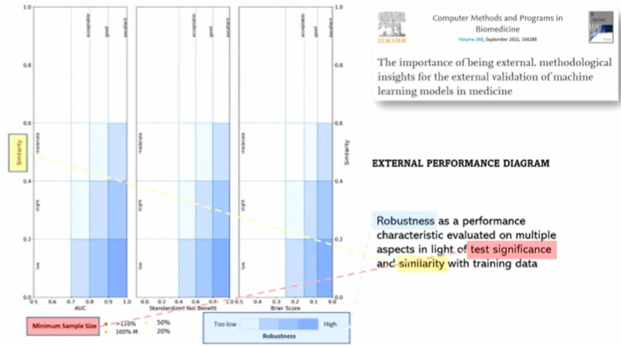
External performance diagram: diagram that only works when you have a dataset that is external, different from the setting of the original data. Try to visualise performance of a model along 3 different dimensions.

- Robustness
- Utility
- Calibration

We see robustness as a performance characteristic that needs to be evaluated on different factors.
- test significance: number of cases we consider in the test
- similarity: of test set to the train set

Usually you have a dataset with a portion on train and the other on a test.

Few people make very simple operations that make the testing totally meaningful.

If a test is very similar on training data is somehow cheating, the test doesn't tell how the system performs on naturally DIVERSE data.

The less similar the test, the better estimate you get when you evaluate the performance of the model. Because you are testing the model with data that are representative and different from what the model saw in the training phase.

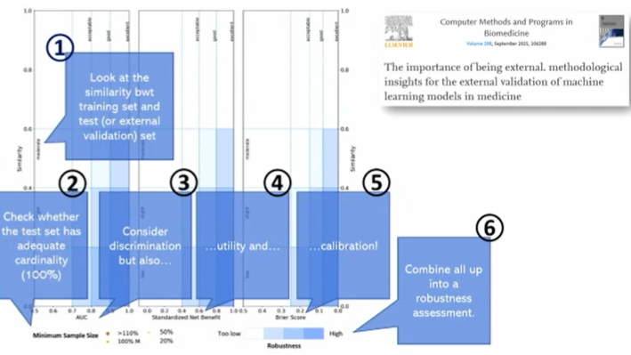
HOW TO READ DIAGRAM
First, compute the similarity between train and test.
Check if the test set has a sufficient number of cases.
Consider three related independent dimensions:
- discrimination
- utility: sort of weighted accuracy
- calibration: if the system can have probability estimates.

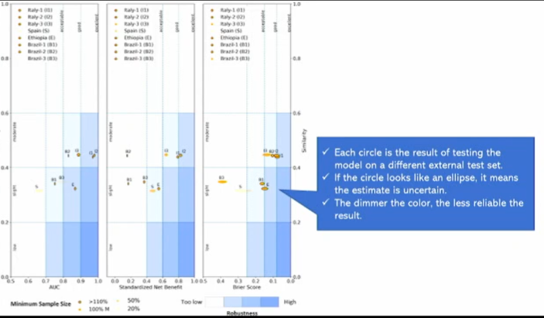
combine in a robustness assessment. The closer to the dark the better it is
the closer the data points the better. Each point is a result of testing the model on different test set

Each point is the performance of the model on specific external tests. The ellipsis is like a confidence interval.

Dimmer colour is less reliable.

Ch3: Interaction in: Human system Interaction - Lec.4
Interaction: word introduced in the 50s, world used in physics, chemistry, genetics and social sciences. Mutual influence between individuals (or groups) through communication processes.

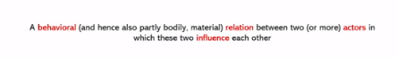

Behavioural: because it is something material that we can observe.

- Entities: what exists, what we can think
- Actors: particular entities that act, influence the environment

We define interaction as a behavioural relation between two or more actors.

⟹ we shape our tools and then our tools shape us
Idea that if we shape our computational skills we are also shaping our cognitive process and ourselves.

Evolution of technology
- The age of punch cards: obsolete, difficult to understand output
- The era of control panels and lights: first interaction with bottoms and lights
- The mother of all demons and conceptual interfaces: mouse
- The personal computer emerges: keyboard on legs + spreadsheets
- The touchpad and touch interfaces
- The rise of the black mirrors
- The voice activated revolution
- Project soli and gesture recognition
- Wearable translation devices
- The alter ego prototype and beyond

Goal: reduction of the interaction friction, try to make machines frictionless as much as possible.

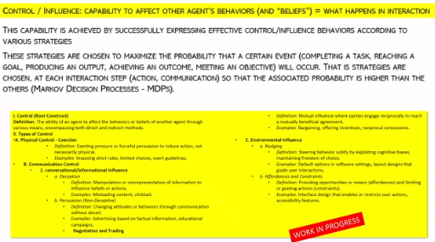
- First concept is CONTROL: capability to affect behaviour of other agents. Is archived by expressing effective behaviour according to various strategies. You have to behave in some ways to affect others behaviour. Maximise the probability that a certain event will occur. Try to make the event more probable. Strategies are chosen at each action.

What types of interaction?
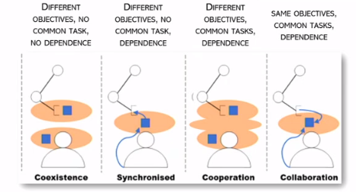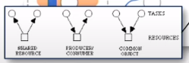

- Coexistence: in space or in time. Context is not overlapping. Agent and systems exist independently. Actors with same objects and not involved in the same task and their work is not dependent on each other
- Synchronisation: human and system working at same time, share same context. Actors do not share high level objectives and not involved in the same task but they are dependent on each other
- Cooperation: Two different contexts but are merging, each of the actors works on their own resources. Actors still have different objects but involved in the same task and depend on each other. We can distinguish between coordination methods
  - Shared resources: different actors that use same resources, can be difficult can compete
  - Producer/consumer: no conflict but consumer has to wait on the producer for the resource. It has temporal constraint
  - Common object: most simple
- Collaboration: deeper integration of efforts towards a common goal
⟹ Another concept common in synchronised, cooperation and collaboration is feedback loop. There is a form of influence just on watching each other, just in seeing where the other system is.

Conceptual Framework:
- Objectives/Higher-Level Goals: The overarching aims or purposes of the actors
involved.
- Tasks/Lower-Level Goals: The specific activities or duties to achieve the objectives.
- Dependence: The extent to which actors rely on each other to accomplish their tasks
or objectives.

Evolving concepts of feedback in Human-Computer Interaction
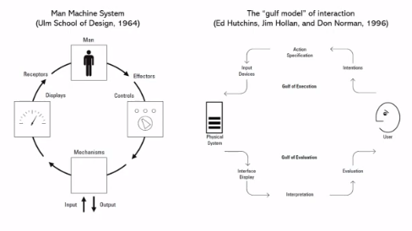

Man machine system model
Man-Machine System Model (Ulm School of Design, 1964):
- This early model, significant in real-time systems like the Apollo program, conceptualises interaction as a loop. It involves humans influencing the system through controls and receiving feedback through user interfaces (initially non-graphical). This concept of feedback loop later evolved in HCI, leading to more complex models.



Gulf Model of Interaction (Don Norman, 1996):
- A more contemporary model, widely recognized in HCI, focuses on bridging the 'gulfs' or gaps in interaction. This model incorporates cognitive psychology, recognizing that humans interpret and react to system feedback, leading to continuous interaction cycles.
- Interface Design and Cognitive Psychology:In the Gulf Model, the role of cognitive psychology becomes prominent. Designers must bridge the gaps in understanding and capability between the system and the user. The model emphasises creating interfaces that are not only responsive to controls but also provide clear, comprehensible information to users.
- Current Trends and Future Directions: Nearly three decades after the Gulf Model, the field of HCI continues to evolve. The interaction is no longer seen as just a reactive process but as a continuous cycle of action and response. The challenge now is to design systems that are not only responsive but also proactive in anticipating user needs.

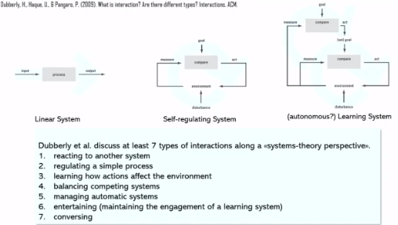
Dubberly’s Model of Interaction:
Dubberly's model, recognized as a significant contribution in the field of human-computer interaction, suggests a new era of interaction design. Facilitate and to make it more effective. Simple feedback is the primary model of interaction with the new richer forms of computing. He proposed 7 types of interactions, and adopted a system-theory perspective. It is a spectrum of interaction from the simple (reaction) to the most complex (conversation).
- Reaction: Basic responses to environmental stimuli.
- Learning: Actions that adapt based on environmental changes.
- Regulating: Managing simple processes within the system.
- Balancing: Maintaining equilibrium between competing systems.
- Managing: Overseeing domain-specific systems.
- Entertaining: Engaging and keeping users interested and engaged (like increasing difficulty when players skills increases). Like videogames and social media
- Conversing: The most complex form, involving peer-to-peer interaction with room for autonomy and learning from each other. Real computational systems are able to conversate with us.
- Continuum of Complexity: This spectrum represents a continuum from simple
reactive systems to complex conversational systems. Each level adds a layer of complexity, indicating a progression from basic control to sophisticated autonomous interactions.

Evolving Concepts of Feedback in Human-Computer Interaction
- Idea to coupled human and machine tiddly to create a partnership
- Want to lower effort, from talking, typing, moving fingers neuralink (Elon Musk) goes to a no-effort interaction with a system, trying to create a communication that is completely effortless.

Ch4: How to design AI System - Lec.5

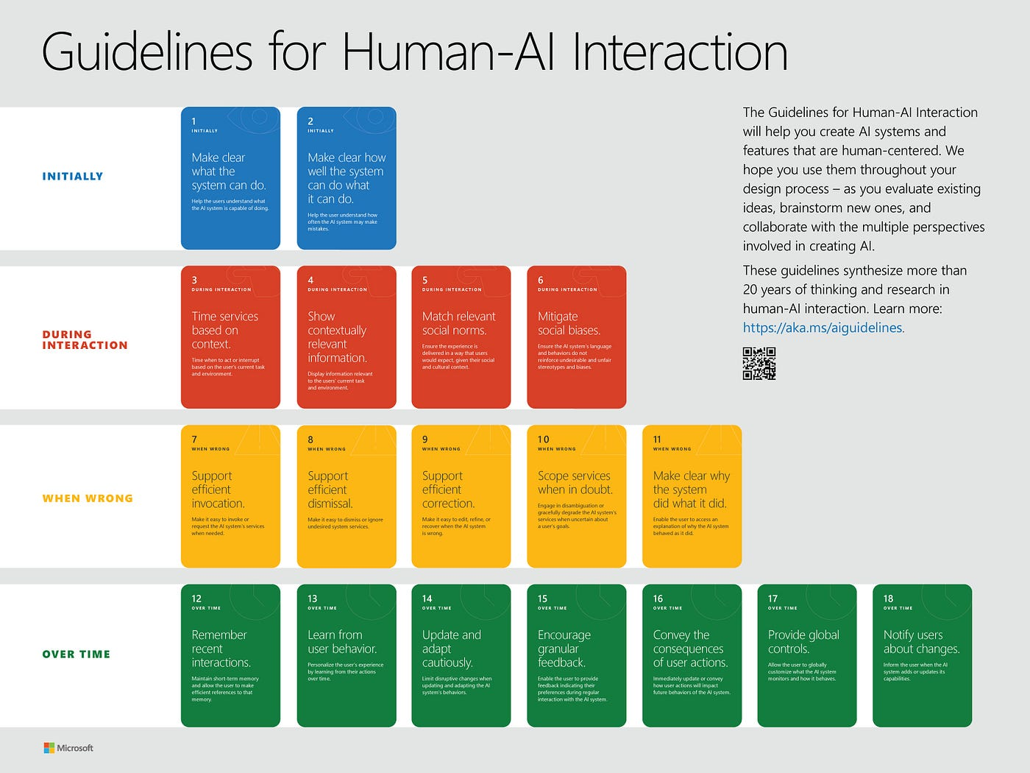

Guidelines for human AI interaction
Microsoft - Washington University Research ⟹ Guidelines for Human-AI interaction, rules on how properly design interaction

Initially - BLUE
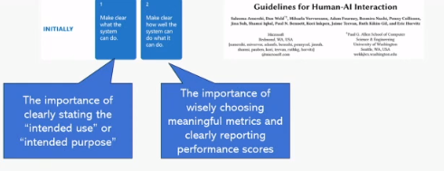
Properly design Human-AI interaction, you need to make clear what the system can do and how well the system can do what it can do. A foundational aspect of interactive AI design is to make explicit what the system is capable of doing.
- Important to state what the function of your AI is (EU AI act article 13, still to be approved). Performance Transparency.
- It is important to choose meaningful metrics and to properly report the performance score.

During Interaction - RED
Guidelines to follow so that the system comply during the use (interaction)

- Time services should be based on context.
- Show contextually relevant info: time and the system notify you when the information becomes meaningful.
- Match relevant social norms: System should not give orders, should be helpful and polite (suggest an edit, do not order one).
- Mitigate social biases: Very general guidelines, make developers aware that social biases exist, do not give you detailed ways on how to mitigate them, suggest that you do your best to mitigate them. Example: an icon with airs not too short or too long, so it can be either male or female, it mitigates social biases of gender. You should not give things for granted, adopt gender neutral icon and warnings (avoid he or she)

When Wrong - YELLOW

- Support efficient invocation
- Support efficient dismissal
- Support efficient correction
- Scope services when in doubt
- Make clear why the system did what it did

⟹ Design not only when things go well but also when things go bad, a key
guideline in this context is to make the system's actions understandable, especially when
errors occur. Make decisions of AI understandable to user (Explainable AI)
⟹ Transparency

Over Time - GREEN
Learn from user behaviour (13) ⟹ make the system capable of learning from user behaviour, it can learn the profile and main characteristic of the user and to adapt.

- Remember recent interactions
- Learn from user behaviour
- Update and adapt cautiously
- Encourage granular feedback
- Convey the consequences of user actions
- Provide global controls
- Notify users about changes

Beyond Methodologies: Designing for Human Experience in AI
When you design an interactive AI system you are designing for the experience the user will have with the system. It is not like making a cake, even if you have a recipe, you have to design an interaction. You need to consider many factors (like human and social factors). It would over-simplify the challenges we have to face.

Dimensions about usability and quality of the interaction
- Task and detailed working activity (DWA) assignment: is a set of activities that are done in a specific way to achieve a specific objective
- Level of automation of tasks and DWAs
- Control/oversight vs heteronomy/autonomy: More autonomy leads to less human control, you have to set the right amount of autonomy that your setting should allow for.
- Human intent vs. machine intent (function): Machine intent is what we call function, machines are not intentional being, it is important to remember that function can sometimes clash with human intent
- Human initiative vs. machine initiative (behaviour): we have to understand how to speak in a specific moment. We do not want machines and humans to talk above each other.

Patterns of Reliance and Protocols of Human-AI Collaboration

How humans could rely on AI systems and protocol of human AI automation. Describes the processes stipulating how humans should collaborate to better achieve the task goal.

- Patterns of reliance: schemas describing how humans can depend on AI systems.
- Concept of protocols of human-AI interaction: particularly collaboration,
stipulates how humans and AI systems should work together to achieve task goals
effectively. Remembering previous classes, we discussed these protocols and
processes in depth, emphasising the importance of effective collaboration.

Parasurama Paper
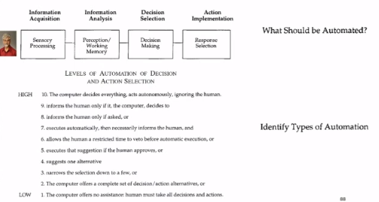

Understand what task to assign to machines and to which level of automation. AI systems designers. The first question should be what task should be automated. We should distinguish between:
- Activities related to information acquisition
- Information analysis
- Decision selection
- Action implementation

Once you have divided the task into some components you need to understand how much to automate.

There is a sort of scale, any kind of level ranking but any ranking would agree that the lowest level is when the compute offer to assistance and human have to take actions and decision, it is an extreme level
- Lowest level: computer offers no assistance, humans make all decisions
- Highest level: computer operators autonomously, potentially disregard human input

⟹ The challenge lies in selecting an appropriate level of automation between these extremes, considering the context, task nature, and user expertise. Usually AI systems providing professional advice to experts are between 3 and 5.

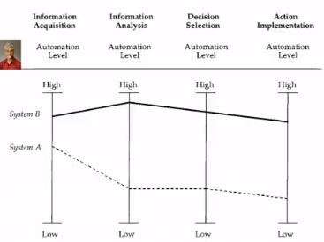

- Different implementations and designs, system A automates some things but leaves to humans other things and system B mainly automated. Deciding what is best depends on the task, context, expertise level of humans, …
- It is not a matter being capable of automating, it is a matter to understand the best for humans. If you delegate all the steps for a machine in the long term you can make damage.
- Designers must consider the long-term consequences of automation on user dependency and skill development.

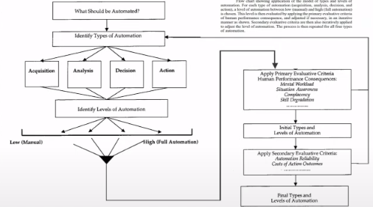
You have to evaluate how good the system is and how well users perform the task when supported by your systems.

Use a primary evaluative criteria to assess consequences of your system on human performance, you have to look at mental workload (it improves, got worse?) Did users become more aware of the situation in which they work? Lost or acquired skills? How the AI system impacted the process of acquisition and maintenance of skills. Might become too easy to delegate to machines.

Daniel Kanheman. Thinking Fast and Slow ⟹ AI systems can enhance efficiency by supporting and improving our cognitive capabilities. This concept, known as cognitive offloading, involves transferring the cognitive burden of specific tasks to machines. Additionally, a key positive effect of AI deployment in critical domains is democratisation.

Balance in Utilising AI systems
There are positive consequences like improving accuracy or fairness. Relying on AI systems in critical situations would make those jobs more fair, because machines will be capable of denoise and improving the work of decision makers.

Clear improvements in efficiency can improve cognitive capabilities and democratisation, the increase is not much significant in important hospitals but has a lot of improvement in a lot of worst hospitals, in those cases there will be a huge impact and improve the outcome of the patient.

- Daniel Kahneman: relying on AI systems in critical decision-making processes and jobs would make those jobs fairer, because these machines would be capable to de-bias and to de-noise. (i.e., remove the variability between decisions, and reduce the possible errors)
- Improvements in efficiency, since AI systems can support our cognitive capabilities -> cognitive offloading.
- Democratisation: decision-support systems can help have an impact in improving the ability of low-resources or low-expertise people (e.g. improving the quality of a small hospital, where complex conditions are not treated often) -> greater access to expertise
- Mitigation of turnover risk (this may risk low vigilance and omission errors, but also reduced effectiveness and resilience. Another issue is defensive behaviour, that is, trusting the machines’”authority” to delegate decisions)

- What the designers of AI systems can control is the second step, where the AI systems provide users with their output. The value of the AI output is the capability of the AI system to change what we decide, and for those decisions, to change the outcomes of those decisions (obviously, the change must be for the better.)
- Patterns of reliance [AI shall have no dominion] (dominance: any kind of influence on human decision making on human action.) a framework, consisting of “patterns”, configurations that tell how much humans rely on AI to make their final decisions.
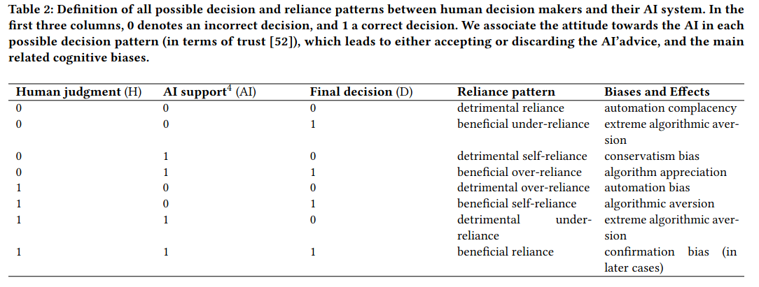
- Detrimental reliance on the AI system: being confirmed by the AI system about a wrong decision didn't help humans in changing that decision.
- Automation complacency: one of the ways in which it is called when you rely on a wrong AI system.
- Four important patterns (rows 4-8):
- Beneficial over-reliance: when the human is wrong, the AI support is right, and the human changes their mind to follow the AI advice, and in doing so, their final decision is right.
-> algorithm appreciation
- Detrimental over-reliance: when humans are right, the AI is wrong, and humans are convinced by the AI system that they should change their mind, and in doing so, they commit a mistake.
-> automation bias
- Beneficial self-reliance: when humans are right, AI systems are wrong, humans neglect the AI advice and still keep confirming their initial decision. In this case, they are right.
-> algorithmic aversion (resistance to the support of machines)
- Detrimental under-reliance: when the humans are right, and the AI is also right. Due to human beings being sceptical against machine output, they change their mind, and this causes a wrong outcome.
-> extreme algorithmic aversion

- Technology impact diagram: a diagram showing the odds ratio.
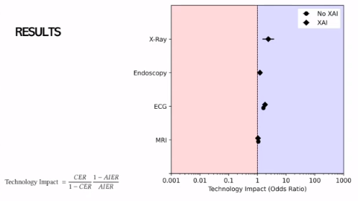

Online tool to generate the diagrams. Demonstrate if a system is valuable or not and if it should buy an AI system or not.

Show the odds ratio: ratio of probabilities of an event. Part of the diagram with good technology impact (blue) or it worsen their performance of people adopting the AI system (red).

Numerator:
- CER: error rate of people who do not hate AI system
- 1-AIER: accuracy of people who support AI system (AIER is the error rate of people who like AI)
Denominator
- Accuracy of people not using AI
- Error rate of people using AI

Different ways in which humans and AI systems can interact:
- Support: tool, no initiative, low autonomy. “human in command”
- Assistance: low delegation, little initiative, same intent, some autonomy, “human in the loop”
- Augmentation: high initiative, complementary intent, some autonomy, “human in the loop”. The goal is a “centaur”, a hybrid decision maker, half human half machine
- Alleviation: heavy human oversight on what the machine does. Humans are controllers, but the machine can exert a high level of initiative and autonomy, “human on the loop”
- Automation: lower human oversight. Machines are almost completely left alone (e.g. selection of CVs in HR), “human on the loop”
- Supplantation: “human out of the loop”. Humans do not continuously monitor the system. It has full initiative and full autonomy. Sort of delegations of human activities to machines

- AFOOT Framework to systematise and simplify the evaluation activities for an evidence-based human AI interaction:
- A: affordances (What? What functionalities? What should be automated?)
- F: fit (How? At what level in the process?)
- O: optimization (How? What should be optimised?)
- O: output (How? How to present information?)
- T: target (Addressed to whom?)

- Independent variables of human-ai design are what you can change, what you could design. (e.g. the affordances, what functionalities to add to your system, what tasks should be automated, what should you optimise, how to present the output, who is the target of your system)

- The dependent variables are decision accuracy, efficiency, utility, and user satisfaction. (value, quality, usability.)

- Human-centred design: “human-centred design is an approach to interactive systems that aims to make systems usable by focusing on the use of the system, and by applying human factors/ergonomics, and usability knowledge and techniques. “ (ISO 9241)

- User experience (UX) is the combination of user perceptions and responses that result from the user or the anticipated use of a system product or service.

- Usability: “the extent to which a system can be used by specified users to achieve specific goals with effectiveness, efficiency and satisfaction in a specified context of use” [remember by heart]
(context is a combination of users, goals, and tasks, resources, and environment.)

